DASHBOARD FEEDBACK

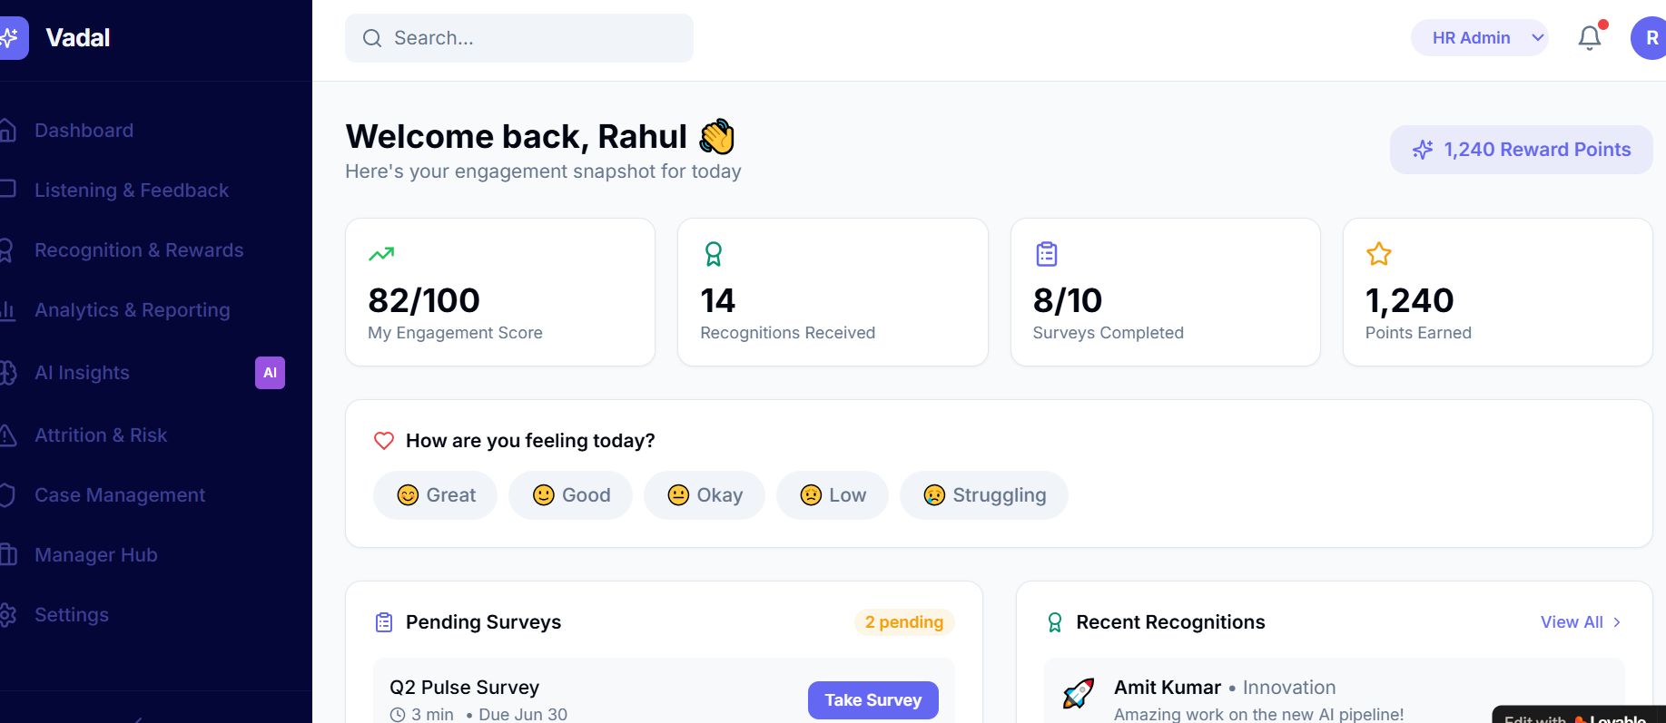Our dashboard is clean and metric-led. However compared to our competition , the gap isn’t just UI, it’s the experience layer. Our competition operates their dashboard as an interactive, drill down, a digital workplace insights + engagement hub, while our dashboard is evolving and still a metrics dashboard.
Core Gap: Experience vs Dashboard - Our platform: Tracks engagement (scores, surveys, recognition) Our competition - Drives daily employee experience (content, communication, community) What we need to enhance, shift: From “HR dashboard” → “Employee daily workspace” I have dwell down what all is missing and what we need to add

Our Core Positioning Engagement + HR Intelligence Platform Employee Experience & Mobile first, Platform AI Listening & Attrition Prediction, Campaign-driven Engagement Platform

What all possible client insights would come in this dashboard

Workforce Health Snapshot How is our client organization really doing today?” Data Headers: Overall Engagement Score, Sentiment Index (Positive / Neutral / Negative), Participation Rate (%), Engagement Trend (MoM / QoQ), High-Risk Employee Count, Benchmark vs Industry / Internal

Attrition & Risk Intelligence- “Who might leave, and why?” for both manager, department head and HR Data Headers: Attrition Risk Score, High / Medium / Low, Risk Segmentation, Top 10 At-Risk Employees / Teams, Key Risk Drivers (Manager, Pay, Role, Workload), Predicted Attrition %, Flight Risk Trend (last 3–6 months)

Employee Voice & Sentiment “What are employees really saying?” Data Headers: Mood Pulse Distribution (Great → Struggling), Open Feedback Themes (AI clustered), Sentiment Trend Over Time, Top 5 Concerns, Escalation Alerts, Anonymous vs Identified feedback split

Recognition & Culture Index “Are we reinforcing the right behaviors?” Data Headers: Total Recognitions, Recognition Coverage (%), Peer vs Manager Recognition Split, Most Recognized Teams, Low Recognition Zones, What people are getting recognized for, Types of top recognitions, Top leaders appreciating teams, Recognition Frequency Trend, Recognition Themes (Innovation, Ownership, Collaboration etc.)
Organisation level - Campaign & Communication Effectiveness“Are our engagement efforts working?”Data Headers: Campaign Reach (%), Participation Rate, Completion Rate, Engagement Score by Campaign, Drop-off Points, • Campaign ROI (Engagement lift %), Drop-off Funnel (start → complete), Communication Open / Click Rates, Communication Open / Click Rates
Team / Department level Campaign & Communication Effectiveness “Are our engagement efforts working?”Data Headers: Campaign Reach (%), Participation Rate, Completion Rate, Engagement Score by Campaign, Drop-off Points, Participation by Function / Location, Engagement Score by Manager / BU, Low Adoption Areas, Campaign Comparison (best vs worst performing teams)

Manager Effectiveness“Which leaders are driving engagement?” Data Headers:Team Engagement Score by Manager, Manager Effectiveness Index, Feedback on Managers (themes), Action Closure Rate, Team Attrition Risk, Managers Teams engagement on the platform under various modules, Recognition Given by Manager

Employee Experience Feed (Daily Experience Layers - “What are employees experiencing daily?”Data Headers: Active Users (DAU / WAU) of last 6 months, 3 months, Content Engagement (Views, Likes, Comments), Community Participation, Most Viewed Announcements, Search Queries / Knowledge Access. Content Relevance Score
A place where user can make a report, after checking make a widget to track it it like actimo wherein the step by step guide to make widget post, report is there. Pl see below
Create Post / Report Issue / Suggest Idea” , Trackable widget (like Actimo journeys
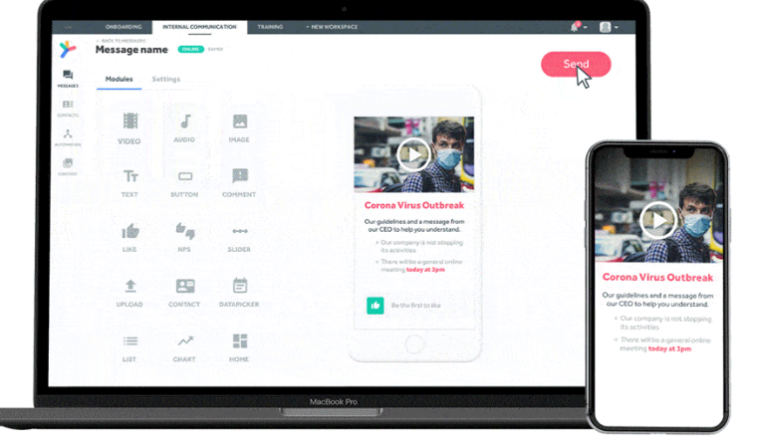

Action & Intervention Tracker, “Are we acting on insights?” Data Headers: Actions Recommended (AI) , Actions Completed, Pending Interventions, Impact Score (Post Action), SLA Compliance, Post-Action Impact Score, Escalation Tracker

Gamification & Participation Index “How engaged are employees behaviorally?” Data Headers: Points Earned, Leaderboard Rankings, Badge Distribution, Participation Frequency, Top Engaged Employees, Drop in Participation Alerts

Knowledge & Communication Hub , How well are we enabling employees?
(I checked in Simpplr it is their core strength) Data Headers: Document Views / Downloads, Policy Access Trends, Search Success Rate, Top Queries, Content Gaps Identified

Business Impact Correlation : Is engagement impacting business outcomes?
(Your biggest strategic differentiator) Data Headers: Engagement vs Attrition Correlation, Engagement vs Productivity / Sales, High Engagement Team Performance, Cost of Attrition, ROI of Engagement Programs

Content & Communication Layer (Biggest Gap) and insights imbedded in the dashboard - Our competition strength: News, announcements, leadership messages, Personalized content feed, Campaign-style communication, Our dashboard: No content layer at all. What we need to enhance, : Central employee feed (like LinkedIn/Workplace). Some insights on Leadership communication and Internal storytelling. Let me explain it further.
Personalized Experience - Our competition focuses on dashboard with : Role, location, interest-based personalization, “What matters to us today” Our dashboard: Same view for everyone, What we need to enhance, : Personalized dashboards, Dynamic widgets based on role, AI-curated content
Social & Community Layer - Our competition focuses in their dashboard section: insights on the Likes, comments, communities, groups, Peer interaction. Our platform: No social interaction. What we need to enhance, : insights on Social feed, Communities (Sales, Tech, Women Network etc.), Commenting & engagement loops
Knowledge & Resource Hub - Our competition focuses in their dashboard section: Policies, documents, FAQs - Searchable knowledge base. Our platform: No knowledge layer .What we need to enhance, : Document repository, Smart search, “Ask HR” / self-service
AI-Powered Experience- Our competition focuses in their dashboard section: AI assistant for search, answers, content Personalized nudges. our platform: No visible AI layer in UI .What we need to enhance, : .AI assistant (“Ask anything”) , Contextual recommendations , Auto insights and hence a place somewhere in dashboard to show AI usages, what they search, leader level insights on similar to sentiment analysis on what people are asking AI
What We Have Engagement Score, Good but No narrative- we need to Add: “Why score changed” “What to do next” (Our approach needs Evolution further basis on this inputs)

Recognition is there – Present but connection with social and more insights at dashboard level. Add: info on Public feed, Comments, reactions

In dashboard - There should be some period selection, like last month, last year etc. and other fileters witing the widget/

Also there are two types of surveys, 1) annual company wide 2) anytime survey which is our brand proposition like amber wherein serveys gets launched basis on the life cycle events of the employees abd finds engagement gaps. Te outcome should be connected in our dashboard that which process is broken and where company needs to strengthen their processes. the biggest strength is we can integrate AI chatbot that proactively talks to employees related and helps them to find the dashboard they are looking at or they need to be working upon. Our dashboard is static (survey + click-based) and What we need to enhance, Continuous listening via chat

Our benchmark partner shows predictive Attrition Intelligence. they shows who is at risk, why, and confidence level. Our “Attrition & Risk” is just a menu item, no visible insights - What we need to enhance, : Risk scores, Early warning signals , “Top 10 flight risks today”

Our partner has clickable further drilling on root Cause Analysis (Why behind data) they drills down: Low engagement because of manager / workload / role clarity . our dashboard shows scores only (82/100) . The urther drill down need to have “Why score is 82?” Driver-level insights (manager, pay, growth, culture)

Manager Action Nudges gives specific actions: “Schedule 1:1 with Rahul”, “Recognition overdue”, etc. What we need to enhance, : AI-driven next best actions Nudges for managers

Sentiment Intelligence (Unstructured Data) Our benchmark company analyzes text, tone, emotion from conversations We have emoji-based input (Great, Good, etc.). we can work on open text sentiment analysis, Theme clustering (burnout, leadership, workload)

What can be added, AI Insights Layer (Game Changer) - “Here’s what needs our attention today”- 3 employees at risk - 2 teams dropping engagement - 5 pending actions

Our tool is planned to identify, issues of the broken HR or Business processes and we can depict it in the Employee Journey View Onboarding → Engagement → Performance → Exit risk

Manager Effectiveness Score Team engagement vs manager is a Strong differentiator. We might need to add Heatmaps – Location / function / manager wise engagement. A widget on Action Closure Tracking - Not just insights → track if action taken

Campaign & Communication Engine (Biggest Gap) Our competition has also built dashboard around campaigns: push messages, quizzes, surveys, nudges in one flow. our dashboard is passive, it waits for users to act

What we need to add - Scheduled engagement campaigns, Multi-channel push (mobile, email, SMS) in the dashboard, Targeted insights by audience, what are the Scheduled engagement campaigns,

Mobile-First Engagement - Our competition is heavily mobile-driven, especially for frontline/workers, Our UI is desktop-first and in I know that the next phase someone will work on how look and feel of the mobile will look like / required. What we need to enhance, : Mobile app experience, Push notifications , move from Offline / low-attention interaction design to interactive action oriented designed as I pointed earlier.

Some insights on Content + Engagement Mix - Our competition blends learning, quizzes, polls, communication. Our platform is focused on HR metrics + surveys. What we need to enhance, : Micro-learning content, Gamified quizzes, Campaign-based engagement journeys

We might have to work little more in insight – dashboard section of Gamification Depth. Our competition has full gamification loop. What we need to enhance, – Leaderboards, Badges, streaks, Team competitions, (later some place we can show integration of Rewards marketplace integration. What we need to enhance, : we can have some dashboard on Micro-learning content, Gamified quizzes, Campaign-based engagement journeys

Segmentation & Targeting - Our competition allows targeted campaigns (location, role, tenure). Our dashboard is generic, same for all users. What we need to enhance, : Persona-based dashboards, Targeted nudges (sales vs corporate vs plant)

What we Have (But Needs Upgrade) Mood Check (Great, Good, Ok) what we can Improve: We can add further drill down on follow-up question: “Why?” Add text input in te dashboard itself for further information. Trigger action based on response

Where we Can Outperform Actimo, Our competition is strong in communication + campaigns, but weaker in deep HR intelligence. we can win by combining using our experience on hiresense. AI + Campaigns “Low engagement in Sales → Trigger campaign” Close loop automatically . Manager Action Layer - Our competition focuses org-wide, Wecan go manager-level actionable

Integrated HR Stack - Wealready have: Attrition, Recognition, Surveys etc. Combine into:

“Employee Health Score + Action Engine”

One-Line Positioning Fix = Move from: “Track engagement” to “Drive engagement through campaigns and actions”

Where We Can Beat Our competition focuses in their dashboard section - is strong in communication, weaker in deep HR analytics. We can win by combining: Engagement + Attrition + AI insights, Manager-level actions , Real-time workforce intelligence. Our Positioning: “Experience + Intelligence platform”

What We Should Add (Priority Order in the dashboard on beautifully add insights on Employee feed (news + recognition + updates), Personalized home experience, Communities & social interaction, Knowledge hub + smart search, AI assistant (Ask HR / Ask Company), Leadership communication layer, In short the Final Take is what we’re solving: “How engaged are employees? and “How do employees experience the company every day?”

If we compare it with hiresense, Biggest Strategic Gap Right now our platform is Data display tool our competitors have AI-driven decision & action tool

Simple Shift to Win Move from: Score → Insight → Action → Impact

In summary – Our Strategic Positioning - Amber: Insight (Why people leave) - Simpplr: Experience (Daily interaction) - Actimo: Activation (Campaigns & participation)
Vadal Opportunity:
“One platform that connects Insight + Experience + Action + Impact”

Business Impact Correlation “Is engagement driving business outcomes?” Data Headers: Engagement vs Performance Correlation, Engagement vs Attrition Trend, High Engagement Team Productivity, Revenue / Sales vs Engagement, Cost of Attrition Bottom of Form

